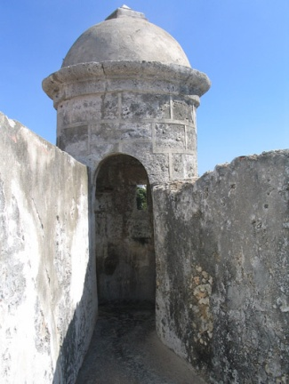

***Visas***

**Country _____________***Cuba***_____________**

**Population** *11,451,652 (2009)*

**Continent _____***Central America***____________**

**Location** *Caribbean, island between the Caribbean Sea and the North Atlantic Ocean, 150 km south of Key West,Florida*

**Capital:** *Havana*

**Area** *Total: 110,860 sq km, land: 109,820 sq km, water: 1,040 sq km*

**Land Boundaries:** *total: 29 km Border countries: US Naval Base at Guantanamo Bay 29 km.*

**Currency** *_______Cuban Peso___________*

**Climate** *tropical; dry season (November to April); rainy season (May to October)*

**Main Religions** *85% Roman Catholic*

**Independence Day**

*Declared, October 10, 1868*

***Interesting Facts***

**Famous Landmarks**

[*Castillo de San Pedro de la Roca*](http://famouswonders.com/castillo-de-san-pedro-de-la-roca/)

*Old Havana*

**Flag Language**

*Spanish*

**Tallest Mountain**

*Pico Real del Turquino elevation 6578 feet.*

**Longest River**

*The Cauto River or Río Cauto, located in southeast Cuba,*

**Natural Resources:** *cobalt, nickel, iron ore, chromium, copper, salt, timber, silica, petroleum, arable land*

**Others**

**Fidel Castro**



image here

Yan Yulius

**Name**

____________ ____________

**Place of Birth Date of Birth**

_____________

**Date of Issue**

Sekolah Ciputra

**Place of Issue**

***The Secretary of State of Sekolah Ciputra Elementary School hereby requests all whom it may concern to permit the national citizen of the Republic of Indonesia named herein to pass without delay or hindrance and in case of need to give lawful aid and protection***

**______________________**

**Signature of Bearer**