HOW THE CROODS ARE DIFFERENT FROM TODAY’S SOCIETY
The Croods | Today Society
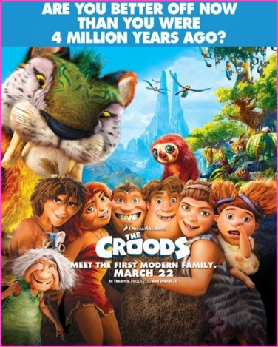 | 