[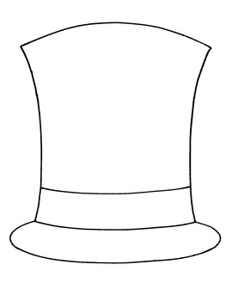](http://www.google.com/url?sa=i&rct=j&q=&esrc=s&frm=1&source=images&cd=&cad=rja&docid=cjhRbL-iUZrMbM&tbnid=LaYmAya03RDxAM:&ved=0CAUQjRw&url=http%3A%2F%2Fwww.teacherspayteachers.com%2FProduct%2Fhats-template-for-6-thinking-hats&ei=bUcTUcPxBtGOmQWA5oBA&bvm=bv.42080656,d.bmk&psig=AFQjCNGA2CcgVG8m3MREmXm9U4LZOnfW2g&ust=1360304347172308)

[](http://www.google.com/url?sa=i&rct=j&q=&esrc=s&frm=1&source=images&cd=&cad=rja&docid=cjhRbL-iUZrMbM&tbnid=LaYmAya03RDxAM:&ved=0CAUQjRw&url=http%3A%2F%2Fwww.teacherspayteachers.com%2FProduct%2Fhats-template-for-6-thinking-hats&ei=bUcTUcPxBtGOmQWA5oBA&bvm=bv.42080656,d.bmk&psig=AFQjCNGA2CcgVG8m3MREmXm9U4LZOnfW2g&ust=1360304347172308)