[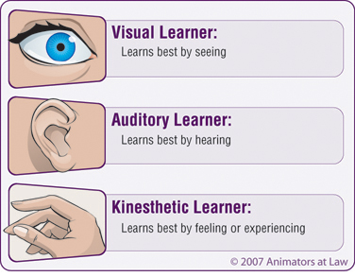](http://www.google.com/url?sa=i&source=images&cd=&cad=rja&docid=P97viR1WR7GLsM&tbnid=xjm1YzILds82nM:&ved=0CAgQjRwwAA&url=http://theteachingthief.blogspot.com/2012/06/how-do-you-learn-eyes-ears-hands-all-of.html&ei=cQUSUeCCDIz9rAe6vIGgBQ&psig=AFQjCNHAf8s6IOClS9PXHQ0NihyZg3qy_Q&ust=1360221937280041)[](http://www.google.com/url?sa=i&source=images&cd=&cad=rja&docid=oquxj4mDmSkCjM&tbnid=W7QBNwt_l7nHRM:&ved=0CAgQjRwwAA&url=http://www.clker.com/clipart-visual-search.html&ei=FAUSUcOJLY3JrAek-oCYDg&psig=AFQjCNHn6UN6_KPA3Wne5yIGGgWi13i94A&ust=1360221844821140)

**What is the video about?**

**Language Mode**: Write any interesting phrase or sentence in the video that showing the main ideas of the video.

**Audio Mode**: Listen to the music, rhythms, melody and beat from the video, and explain how they fit with the message found in the clip.

**Visual Mode**: Watch, list and describe any still/ moving pictures, image, animation in the video clip which supports the purpose of the video.